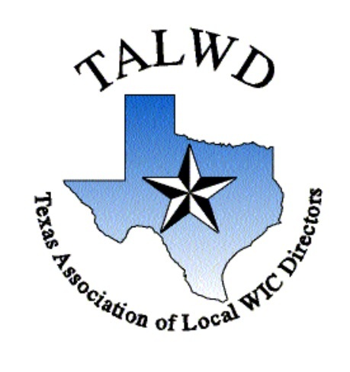
TALWD Purpose Statement
The purpose of the Texas Association of Local WIC Directors shall be to act as a vehicle for the expression of ideas on planning, policy, coordination, implementation, and administration of the WIC program on the Local, State, and Federal level; to foster communication between local WIC programs and the Texas Department of Health with the goal of positively affecting the administration of WIC within the state; to bring together administrators of Local Agency WIC Programs, in order to provide peer support, orientation and/or assistance; and to promote professional and public awareness of new and existing Federal and State legislation.
From the Editor: Please contact us, if you have suggestions or story ideas. Hope you enjoy Volume 5, Issue 28
Meliza Garcia, Newsletter Reporter
Email: mgarcia@sanpatriciocountytx.gov
2024 TALWD Board Members: | Committee Chairs: | Regional Representatives &Alternatives:
President – Benny Jasso  Secretary – Jennifer Gregory  Treasurer – Jessica Neal  1st VP of Organization & Development – Brandy Patteson  2nd VP of Operations – Jennifer Ranspot  NWA Representative – Adela Garcia  NWA Rep-Elect – Tecora Smith  Newsletter Reporter – Meliza Garcia  Historian – Clarissa Ramirez  Past Presidents Council Representative – Eileen Mendoza | Business & Finance Chair – Margaret Payton  Legislative Chair – Michelle Cummings  Marketing Chair – Jannette Sepeda  Membership Chair – Amanda Brogdon  Nutrition Education Chair – Kathryn Almaraz  Breastfeeding Chair – Zahra Koopaei  Client Services Chair – Jammie Wright  Local Agency Administration Chair – Kelly Bocanegra  Technology Task Force –Brandy Patteson  Funding Formula Task Force – Margaret Payton  Re-Opening Task Force – Amanda Brogden  QA Task Force – Eileen Mendoza | Central Representative – Alissa Orozco  *Alternate – Nicole Koenen  Panhandle Representative – Eileen Mendoza *Alternate – Margaret Payton  Western Representative – Vacant  *Alternate – Adriana Archer  Northern Representative – Janice Piper  *Alternate – Kathy Oliver  Gulf Coast Representative – Becca Reed  *Alternate - Zahra Koopaei  Southwestern Representative – Julie Granado  *Alternate – Mandi Wilcox  Eastern Representative – Scherry Barnes  *Alternate – Kristi Kilgore  Southern Representative – Kathrine Galvan  *Alternate – Yvette Viciniaz

TALWD Membership Renewal
Have you renewed your TALWD membership for the upcoming year? TALWD memberships expire each year on December 31st.
Learn More
 https://talwd.org/images/userfiles/file/Membership/20230106122502_6_2023TALWDMembershipDuesForm.pdf
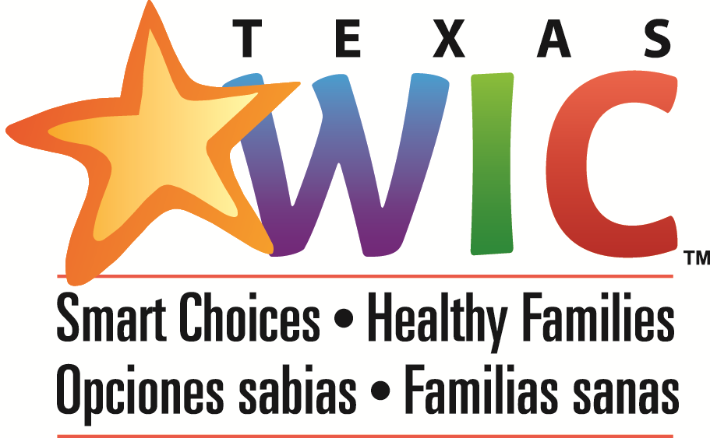

WIC Weekly Memos and Bulletins

Number | Title/Notes | Date Published
24-008 | House Bill 12 Medicaid and CHIP Postpartum Coverage Extension | 03/06/2024
24-012 | March 2024 Formula Approval Resources | 03/05/2024
24-011 | New TXIN and myWIC Release Summary List | 02/28/2024
24-010 | Migration to Qualtrics Gov-1 Timeline and Job Aids | 02/15/2024
24-009 | New trainings, updated schedule available for February, March and April | 02/15/2024
24-007 | Disability Determination Letters | 02/12/2024
24-006 | Breast Pump Ordering Opportunity | 01/29/2024
24-005 | WISE Report Due to the State Agency by April 30, 2024 | 01/29/2024
24-004 | Prenatal Education Bag Ordering Opportunity | 01/17/2024
24-003 | Clarification to WIC Policy Memo #23-074 - Revisions to Texas WIC Policy, CS:10.0 | 01/11/2024

Upcoming Breastfeeding Courses – 2024
Contact:
Missy Hammer
(512) 413-5709
Missy.Hammer@hhs.texas.gov

Breastfeeding Course Information
The Health and Human Services, Texas WIC Program collaborates with the Texas Association of Local WIC Directors (TALWD) to provide current, evidence-based lactation education to ensure consistent, accurate information across all levels of health care professionals. Courses are offered virtually, in-person, and on-demand. If your facility would be interested in hosting an in-person Lactation Principles class, please use the Contact Us feature.
Online
Breastfeeding Management and Breastfeeding the Compromised Infant are offered online to take at your own pace. No pre-requisites and no cost.
- Texas WIC employees must take the classes on the Texas WIC Training site.
- Non-WIC employees must take the classes on our site for WIC Partners.
- If you have questions or problems, email WICPartnerTraining@hhs.texas.gov
Live Classes

Classes are offered in-person and/or virtually. Virtual classes are free to attend and require attending orientation at least once on the learning platform, Livestorm, lasting about 20 minutes. Virtual classes are spread out over the course of several days. Registration is required in advance and closes a week prior to the class.

Who Should Attend

Live courses are designed for local agency WIC staff and health professionals who counsel breastfeeding mothers and would like to improve problem-solving and counseling skills. The classes emphasize critical thinking. You will work through case studies and activities as a group. Be prepared to join the discussions and share your ideas with others in class. There will be no written handout or syllabus so you can focus on discussions.
Active engagement is assessed in this virtual platform using participation via chat and polls. Evidence of consistent active engagement throughout the entire session day is required.

Advanced Lactation Management: Session 3
Monday, March 18, 2024, 1:00pm – 5:00pm online only
Advanced Lactation Management: Session 4
Wednesday, March 20, 2024, 1:00pm – 5:00pm online only
Lactation Principles (in-person)
Thursday, April 11, 2024, 8:00am – 5:00pm
City of Houston Fifth Ward Multi-Service Center
4014 Market St.
Houston TX, 77020
Lactation Principles (virtual)
5/13/2024 – 5/16/2024, 9:00am – 12:00pm online class over 3 consecutive days
Advanced Lactation Management: Session 1
Monday, July 15, 2024, 1:00pm – 5:00pm online only
Advanced Lactation Management: Session 2
Wednesday, July 17, 2024, 1:00pm – 5:00pm online only
Advanced Lactation Management: Session 3
Monday, July 22, 2024, 1:00pm – 5:00pm online only
Advanced Lactation Management: Session 4
Wednesday, July 24, 2024, 1:00pm – 5:00pm online only
Lactation Principles (virtual)
8/12/2024 – 8/15/2024, 9:00am – 12:00pm Online class over 3 consecutive days
Advanced Lactation Management: Session 1
Monday, September 9, 2024, 1:00pm – 5:00pm online only
Advanced Lactation Management: Session 2
Wednesday, September 11, 2024, 1:00pm – 5:00pm online only
Advanced Lactation Management: Session 3
Monday, September 16, 2024, 1:00pm – 5:00pm online only
Advanced Lactation Management: Session 4
Wednesday, September 18, 2024, 1:00pm – 5:00pm online only
Advanced Lactation Management: Session 1
Monday, December 2, 2024, 1:00pm – 5:00pm online only
Advanced Lactation Management: Session 2
Wednesday, December 4, 2024, 1:00pm – 5:00pm online only
Advanced Lactation Management: Session 3
Monday, December 9, 2024, 1:00pm – 5:00pm online only
Advanced Lactation Management: Session 4
Wednesday, December 11, 2024, 1:00pm – 5:00pm online only

TXIN and myWIC Live Trainings Start This Week
Check out the Live Training Schedule for full details on upcoming training opportunities.

Lunch and Learn: Ask the IBCLC

 | Date: Tuesday, March 12  Time: 1-2 pm CST  This session will allow LA staff who counsel breastfeeding moms the chance to ask our IBCLCs any questions they may have.  Join Here

Lunch and Learn: myWIC Tips and Tricks III

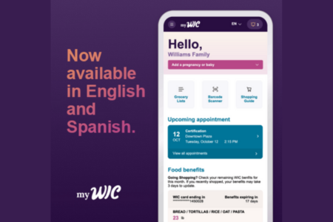 | Date: Thursday, March 14  Time: 12-1 pm CST  Join us to learn, share and discuss tips and tricks to help your clients with myWIC.  Join Here

Register Now
Guest speakers will present live on Zoom and be recorded in the WIC LMS for future viewing. Please register in advance. Visit registration pages for more details. Contact Angela Gil if you have any questions.

WIC Leadership Series: Building Up Your Team – Improving Morale

 | Date: Wednesday, April 3  Time: 12-1:30 pm CST  In this fast-paced session, we’ll experience hands-on activities that can be applied in our own environments immediately. We’ll evaluate our team’s status and see how to move them forward. Be ready to gain principles for building others up and enhancing morale. Awarded 1.5 CPEU.  Register Here

Hardwiring Happiness

 | Date: Thursday, April 18  Time: 12-1 pm CST  In this workshop, Dr. Shauna Shapiro, an internationally recognized expert in mindfulness, will teach you powerful practices to live a happier, healthier, more meaningful life. Awarded 1.0 CPEU.  Register Here
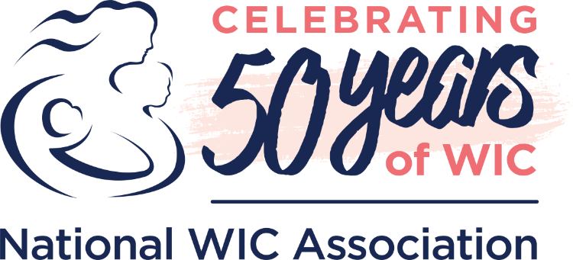

Press Releases
TALWD 2024
ANNUAL MEETING
Nominees
Our Art Fuston nominee is: Jenifer Gregory:
Jenifer is kind hearted, always got your back, kinda gal. She has been instrumental in myWIC and various other technology discussions and recently became TALWD's Secretary, all while running an agency of her own. Jenifer is a huge inspiration to me and I admire her determination, "can do" attitude, and her caring demeanor. Jenifer deserves to be recognized as our Art Fuston Award recipient as a result of her stellar performance and massive participation in the TALWD board activities. She supports, promotes, and is all about making Texas WIC the best it can be!
Our Customer Service Nominee is: Tammy Jimenez:
Since joining at the State level, Tammy Jimenez had to get all program requirements organized and caught up related to her new WCS Preceptor role at the State. I have no doubt that this took countless hours of her time and I can only imagine some of the stress that resulted from it. Yet, she has pushed through and I can see how her hard work is already beginning to shine through related to the WCS Candidate training program. On top of this, she became our LA's State Agency Partner (SAP) and I can only say a huge thank you to her. She has not been in the role long, but I already feel her efforts have improved our abilities to interact with our SAP and identify the answers we need to complete our LA demands. Thanks Tammy for your hard work, kind actions, and support!

March 11, 2024

BIDEN’S PROPOSED FY25 BUDGET DEMONSTRATES CONTINUED COMMITMENT TO WIC, CONGRESS MUST FOLLOW SUIT
Today, the Biden Administration released its proposed fiscal year 2025 budget that includes $7.7 billion in funding for the Special Supplemental Nutrition Program for Women, Infants and Children

March 8, 2024

NATIONAL WIC ASSOCIATION COMMENDS CONGRESS FOR PASSAGE OF GOVERNMENT FUNDING BILL THAT INCLUDES MORE THAN $1 BILLION IN ADDITIONAL FUNDING FOR WIC
Today, the Senate passed legislation funding several executive branch agencies for the remainder of the fiscal year, including the Department of Agriculture (USDA). Included in USDA’s nutrition title is a funding increase of more than $1 billion for the Special Supplemental Nutrition Program for Women, Infants and Children (WIC).

March 3, 2024

NATIONAL WIC ASSOCIATION APPLAUDS MORE THAN $1 BILLION IN ADDITIONAL FUNDING FOR WIC IN NEW GOVERNMENT FUNDING BILL
This bill marks a seminal moment in the 50-year history of the WIC program. If members of Congress approve this legislation — and we urge them in the strongest possible terms to do so

February 28, 2024

STOPGAP AGREEMENT ON GOVERNMENT WOULD AVERT SHUTDOWN, FAILS TO PROVIDE LONG-TERM FUNDING FOR WIC
While we’re grateful that lawmakers are making progress on full-year funding bills, it’s disappointing that WIC families once again have to endure Congress prolonging their uncertainty about the stability of the program

February 27, 2024

NATIONAL WIC ASSOCIATION COMMITS TO SUPPORTING WHITE HOUSE CHALLENGE TO END HUNGER AND BUILD HEALTHY COMMUNITIES
We are confident that America can end hunger and reduce diet-related diseases by 2030 and the National WIC Association is pleased to do our part to help achieve those goals.

Media Coverage

Agri-Pulse | March 8, 2024

OPINION: WIC GOT THE FUNDING INCREASE IT NEEDED. HERE’S WHAT MUST HAPPEN NEXT
With WIC funding secured for the remainder of the fiscal year, families on WIC can breathe a sigh of relief — but only for a moment. The past fifty years have taught us that a better future for children and families is earned, not given. Today, we happily celebrate a big victory. Tomorrow, we roll up our sleeves and continue the fight.

The New Republic | February 28, 2024

THE REPUBLICANS’ PLAN FOR ANTI-HUNGER PROGRAMS COULD LEAVE SOME NEEDY FAMILIES BEHIND
Beneficiaries of SNAP and WIC might end up getting caught in the crossfire of a proposed funding deal.

Salon | February 26, 2024

"CUT THE PARTISAN GAMES": HOW HOUSE REPUBLICANS COULD FORCE A CHOICE BETWEEN SNAP AND WIC
WIC may get the additional funding it desperately needs — but there's a really big catch

NBC News | February 20, 2024

WIC FACES A BUDGET SHORTFALL. FOR MILLIONS OF WOMEN AND YOUNG CHILDREN, MORE THAN NUTRITION IS AT STAKE.

“It’s an investment in the overall health of your children,” said one mother who participates in WIC, which has been shown to increase rates of prenatal care, breastfeeding and childhood immunizations.

National Journal | February 14, 2024

SOME REPUBLICANS WHO PUSHED TO RESTRICT ABORTIONS WORK TO RELIEVE FINANCIAL ‘BURDEN’ OF PREGNANCY
Proposals like the expansion of the child tax credit and the Special Supplemental Nutrition Program for Women, Infants, and Children (WIC) have gained favor with Republican Sen. Marco Rubio, who says he wants to ensure that pregnancy is not a “burden.”



Join NWA's WIC 50th Anniversary Giving Campaign - Download the Toolkit

Join NWA in celebrating WIC's 50th Anniversary in 2024 through our Giving Campaign. From Giving Tuesday to end-of-year contributions, social media interactions, and personal outreach, we're on a mission to raise funds and amplify awareness about WIC's crucial role in providing health and nutrition support.
This toolkit includes instructions on starting a Facebook fundraiser, sample social media posts, graphics, and model email copy to share with your loved ones. We invite all NWA members to spread the word and contribute to our cause.
Download the Toolkit



Embrace the Milestone Year with NWA Membership Renewal
This past year has marked incredible strides for WIC and NWA. NWA's efforts have ensured that WIC remains a priority for lawmakers, emphasizing member-centric programming and innovative practices that enrich the WIC participant experience. As we approach the NWA membership renewal season, we deeply appreciate your support, which has been instrumental in our progress. Looking ahead to the 50th anniversary of WIC in 2024, your continued membership will be pivotal in our efforts to support our mission.
Explore highlights of what we accomplished in 2023 here and learn more about member benefits here. The deadline for membership renewal is December 31, 2023. Thank you for being an essential part of our community and for your ongoing support. If you have any questions, please don't hesitate to contact us at membership@nwica.org.

Renew Your Membership

NWA Webinars
We invite NWA members to explore our various WIC-related webinars. We offer webinars on Thursdays from 3:00 - 4:00 pm ET unless otherwise noted. See below for a schedule of upcoming webinars.
You can also watch our archived webinars on-demand on the NWA Online Community On-Demand Webinars Group. The community is for WIC agency staff with active NWA membership. If you have issues accessing the online community, please email us at membership@nwica.org.

To attend NWA webinars, you must register in advance. The links below will take you directly to registration. Upon completing your registration, you will receive a confirmation email. If you don't see that email, please check your spam/junk mail folder. We strongly recommend you add no-reply@zoom.us and membership@nwica.org to your email safe senders list to be sure you get your confirmation and other important emails about the webinar.

All About the WIC Hub
Thursday, March 7th, 3:00 pm ET
Register here
Speakers:
- Jenniffer Duran-West, IBCLC, MCH Specialist II, Lundquist WIC program
- Marian Schenck, Vendor Policy Planner, Louisiana Bureau of Nutrition Services
- Sanaa Farran, Nutritionist, South Carolina WIC
Join us in exploring the world of WIC with the WIC Hub, a website featuring the work of WIC staff, researchers, and advocates. Discover all the resources and information dedicated to WIC, conveniently accessible through the Hub. Join our webinar to delve into the functionalities of the Hub, learn how it can enhance your work, understand the process of submitting your resources, get a live demo of the website, and much more!

Implicit Bias
Thursday, April 18th, 3:00 pm ET
Register here
Speakers:
- Brisa Chavez, CLC, NWA Health Equity Champion, WIC Lead Educator, Garfield County Public Health
- Adela Garcia, NWA Health Equity Champion, WIC Manager, Childrens Hospital of San Antonio
- Alejandra Arellano, MPH, CLE, NWA Health Equity Champion, Health Equity Manager, Lundquist Institute for Biomedical Medical Innovation at Harbor-UCLA Medical Center
This session will explore the definition of implicit bias. It will help develop an understanding and awareness of how implicit biases are formed and how they impact interactions with others in the workplace. We will provide examples that we come across in the WIC Program, ways to help overcome our own biases, and resources to continue expanding awareness.

Explicit Bias
Thursday, April 25th, 3:00 pm ET
Register here
Speakers:
- Asia Bangura, NWA Health Equity Champion, Nutrition Counselor, CCI Health Services
- Sonia Gamble, NWA Health Equity Champion, Dietitian Supervisor, Franklin County WIC
- Tonce Jackson, ED.D., MPH, RDN, CLE, NWA Health Equity Champion, Senior Health Equity Manager, Public Health Foundation Enterprises-WIC
- George Rivera, NWA Health Equity Champion, Regional Manager, Pennsylvania Department of Health-WIC
This presentation aims to provide a comprehensive understanding of explicit bias, its distinctions from implicit bias, practical examples, and effective strategies to promote awareness and mitigate its impact.
Objectives:
- Clearly articulate what explicit bias is, emphasizing its conscious and intentional nature
- Highlight the distinctions between explicit bias (conscious attitudes and beliefs) and implicit bias (unconscious biases that influence behavior).
- Discuss the potential negative consequences of explicit bias, both on an individual and societal level.
- Develop strategies to raise awareness about explicit bias, emphasizing the importance of recognizing and addressing it to foster inclusivity.
- Self-Reflection

All registered attendees will receive the following within a week of the live webinar broadcast:
- A link to the Webinar Recording on the NWA Online Community
- Slides (If approved by the Presenter to Share)
- Certificate of Attendance
- CDR and/or IBCLC Continuing Education Certificate (If offered)
Have a webinar question or idea? Email us: membership@nwica.org.

NWA Events

April 7-10, 2024

2024 nwa annual education and training conference
WE ARE GOING TO CHICAGO!
We are pleased to announce the 2024 NWA Annual Education and Training Conference will be held in Chicago, Illinois, April 7 - 10, 2024.
The Conference will offer an excellent opportunity to acquire new skills and to network with an estimated 1,200+ of your peers, and colleagues along with exhibitors who will provide WIC related products and services for participants.
Registration will open in January.
For questions, please contact the NWA National Office at ConfSupport@nwica.org

Quick Links
- View the Program and Other Event Details
- Register

November 19-21, 2024

2024 nwa nutrition education & breastfeeding promotion conference
Save the date! The 2024 Nutrition Education & Breastfeeding Promotion Conference will take place in Baltimore, Maryland on Tuesday, November 19 – Thursday, November 21!
Abstract Call Opening Spring 2024!
Registration Opening Summer 2024

Quick Links
- View the Program and Other Event Details
- Register

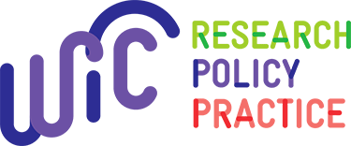

RESOURCE COLLECTIONS

SECONDARY DATASETS AVAILABLE FOR USE IN WIC RESEARCH
This collection serves as a directory of secondary datasets related to WIC available for researcher use. NWA maintains an active list of these datasets, which are all either publicly available […]
8 Resources
View the Secondary Datasets Available for Use in WIC Research Collection

ADVANCING HEALTH EQUITY TO ACHIEVE DIVERSITY & INCLUSION (AHEAD) IN WIC PROJECT
In 2019, the National WIC Association (NWA) received a grant from the Walmart Foundation to support a two-year project aimed at Advancing Health Equity to Achieve Diversity & Inclusion (AHEAD) […]
14 Resources
View the Advancing Health Equity to Achieve Diversity & Inclusion (AHEAD) in WIC Project Collection

POWER YOUR MISSION: HUMAN-CENTERED TECHNOLOGY AND WIC
The National WIC Association (NWA) is thrilled to announce the formation of the WIC Technology Resource Group, a resource and learning partnership between NWA and Nava, a government technology consultancy […]
7 Resources
View the Power Your Mission: Human-Centered Technology and WIC Collection

CASH VALUE BENEFIT INCREASE
This is a special collection of NWA-developed resources about the cash value benefit (CVB) increase. For NWA resources on other topics, please see the NWA Resources page.
4 Resources
View the Cash Value Benefit Increase Collection

CHILD NUTRITION REAUTHORIZATION RESOURCES
Child Nutrition Reauthorization (CNR) is the primary vehicle to enhance WIC. The program stands at the intersection of food security and public health. These complementary supports are critical in achieving […]
8 Resources
View the Child Nutrition Reauthorization Resources Collection

WIC COORDINATION AND OUTREACH
This collection contains examples of coordination between WIC and other programs and services, including co-location with healthcare, integration with home visiting and other partnerships. It also contains examples of targeted […]
10 Resources
View the WIC Coordination and Outreach Collection

STORYCORPS VIDEOS
The National WIC Association (NWA) partnered with StoryCorps and the Robert Wood Johnson Foundation to gather stories from WIC participants during the COVID-19 pandemic. These stories represent the diversity of […]
8 Resources
View the StoryCorps Videos Collection

WIC APPLICATION TOOLS
This collection contains online tools implemented by WIC state and local agencies to help families apply for WIC services. These include eligibility screeners, pre-applications, appointment request forms, and full program […]
11 Resources
View the WIC Application Tools Collection

FOOD PACKAGE
This is a special collection of NWA-developed resources about the WIC food package. For NWA resources on other topics, please see the NWA Resources page.
23 Resources
View the Food Package Collection

EQUITY, DIVERSITY, AND INCLUSION IN WIC
For the National WIC Association (NWA), health equity is the ability of all individuals and families to achieve optimal health, irrespective of their identity, race, ability, or class. This requires […]
17 Resources
View the Equity, Diversity, and Inclusion in WIC Collection

COVID-19 RESOURCES FOR WIC
This is a collection of resources to help WIC agencies navigate and respond to the COVID-19 pandemic.
24 Resources
View the COVID-19 Resources for WIC Collection

WIC INNOVATION
This is a special collection of NWA-developed resources about WIC innovation. For NWA resources on other topics, please see the NWA Resources page.
4 Resources
View the WIC Innovation Collection

NWA RESOURCES
WIC-Related Fact Sheets, Position Papers, Toolkits, and Statements produced by the National WIC Association.
As the education arm and advocacy voice of WIC, NWA produces fact sheets, position papers and toolkits to support WIC advocacy and education. Browse the selection below to find resources to support your work.
- WIC IMPACTS
- WIC PARTICIPANT RECRUITMENT AND RETENTION
- WIC ADVOCACY
- WIC PROGRAM FUNDING AND OPERATION
- BREASTFEEDING
- MATERNAL AND CHILD HEALTH
- WIC INNOVATION
- WIC STATE PROFILES

ACTION CENTRAL
2024: KEEPING WIC STRONG FOR THE NEXT 50 YEARS
For 50 years, WIC has been at the center of positive public health outcomes, championing access to healthy food, breastfeeding support, health screenings, and referrals. WIC providers have been consistently innovating to reach more eligible families and lean into a more modern service delivery model. Effective measures adopted in recent years – including the evidence-based expansion of WIC’s fruit and vegetable benefit and introduction remote service options – are positioned to become longer-term tools that can be leveraged to present WIC as a modern and accessible program that delivers targeted and impactful nutrition support at critical times of growth and development. Reframing WIC and harnessing the progress of State and local innovations will require the collective voice of WIC providers, stakeholders, and advocates to build momentum for a modern WIC. In 2024, WIC reforms can be accomplished through:
- Appropriations: The annual process to fund federal programs, including WIC. WIC will need to secure increased investment to account for the challenges of an increase in caseload. The WIC caseload increased by 5% in fiscal year 2023, from 6.4 million participants to 6.7 million. This trend of an increased caseload has been consistent across participant categories. Funding will also be needed to improve Management Information Systems to ensure timely and swift implementation of updated WIC food packages.
- USDA Rulemaking: USDA proposed science-based updates to the WIC food packages in November 2022, including steps to make the expanded fruit and vegetable benefit permanent. More recently, USDA also proposed updates to WIC vendor regulations. These updates are anticipated to be released soon.
- Enhancing Remote Services: In recent years, USDA has had the authority to waive physical presence requirements to provide remote services and/or remote benefit issuance to evaluate the modernization of WIC services and increase access to WIC benefits through September 2026. WIC modernization efforts, like remote appointments, have made connecting with and remaining on WIC easier, which is why we need to build on current progress.
- Authorizing Legislation: Despite numerous bipartisan attempts in recent years, WIC has not been reauthorized since Congress passed the Healthy, Hunger Free Kids Act in 2010. As the Agriculture Committees continue to work on advancing a Farm Bill, there are new opportunities to improve linkages between SNAP and WIC, particularly in the retail space. Despite the focus on the Farm Bill, NWA is working to build support for urgently needed WIC reforms, such as the Wise Investment in our Children Act (WIC Act), the MODERN WIC Act, and the WIC for Kids Act.

TAKE ACTION TO STRENGTHEN WIC
With potential reforms on the table, now is the time to engage with the National WIC Association and help usher in the next generation of WIC services. In 2021, the National WIC Association convened the WIC Action Network to keep grassroots supporters informed and strengthen public education efforts about WIC services during COVID-19. Connect with the WIC Action Network to hear about the current policy landscape and plug in with opportunities to raise your own WIC voice. Learn more about current WIC priorities with the following resources:

NWA PRESS RELEASES
Mar 11 2024

Biden’s Proposed FY25 Budget Demonstrates Continued Commitment to WIC, Congress Must Follow Suit
Mar 8 2024

National WIC Association Commends Congress for Passage of Government Funding Bill That Includes More than $1 Billion in Additional Funding for WIC
Mar 3 2024

National WIC Association Applauds More than $1 Billion in Additional Funding for WIC in New Government Funding Bill
More Press Releases from NWA

NWA BLOG POSTS
Mar 6 2024

blog test
Mar 1 2024

Black History Month Highlight: Sonia Gamble
Feb 27 2024

Empowering Families through Nutrition: The National WIC Association's Commitment
More Blog Posts from NWA
Contact Nell Menefee-Libey at nmenefeelibey@nwica.org.

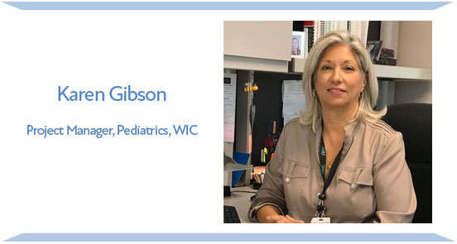

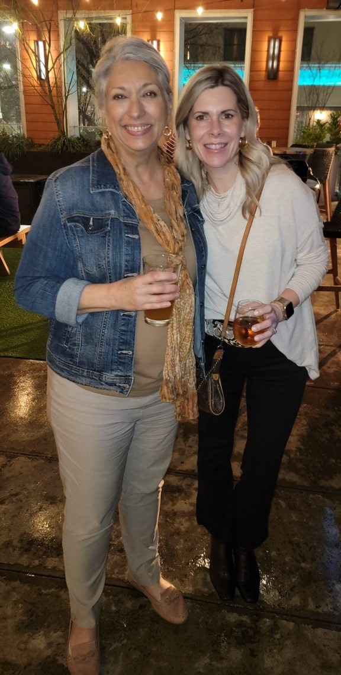
Happy Retirement!
Karen Gibson started her career with UT Health in 1985. At the time, she was working as a dietitian with the City of Houston Health Department for their WIC (Women, Infants, and Children) Program. When she learned of an opening at UT Health for a Nutrition Education Coordinator for their WIC Program contract from a co-worker, she applied. This was an easy decision to make as it was a promotion and she would become a part of the University of Texas System-as Karen is a UT-Austin graduate herself. In 1992, she was promoted to WIC Program Director and has been there ever since. Karen served in TALWD for many years and in various roles. She is a past Art Fuston Award Recipient and has contributed countless hours to help insure local agencies have a voice and were well-represented when working with our State Agency. She is a strong advocate for the WIC program and has shared a wealth of knowledge and experience with her peers. Her contributions to Texas WIC and TALWD will
be greatly missed. Karen, you are a great friend and peer! Many blessings on your retirement!
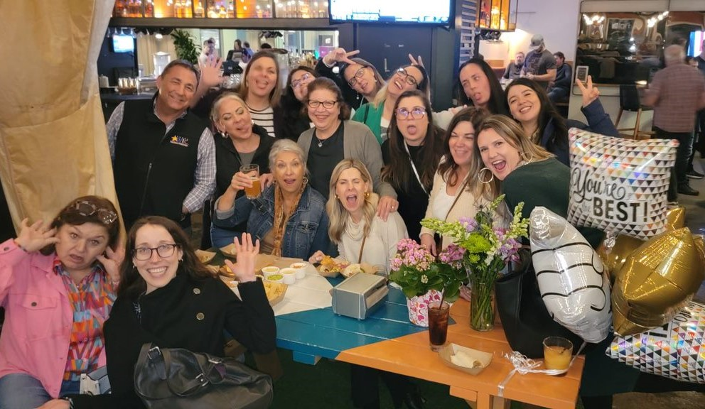
We wish you all the best and thank you for all you have done!!!

